Login to CyberArk portal of below any of the link on Bayer desktop.And user should have the correct passwd.
https://pas-fr.bayer.biz/PasswordVault/v10
https://pas-br.bayer.biz/PasswordVault/v10
https://pas-sg.bayer.biz/PasswordVault/v10
https://pas-va.bayer.biz/PasswordVault/v10
or
https://pas-fr.bayer.biz/PasswordVault/v10/Classic/myaccounts.aspx?Data=XkBeXkBeMF5AXjYwOWVmMGU5LTJkOTMtNDE2NS04ZTU4LTllMWQyNDU5Yzc2ZF5AXk15Vmlld3NeQF4wXkBeRmFsc2VeQF44ODNiNzg1ZTE1MmE0MWNlOGIyM2Y3MWVkZDY4MWVhZl5AXkJhY2tVUkw9TXNnRXJyPU1zZ0luZm89

click on 2cwid
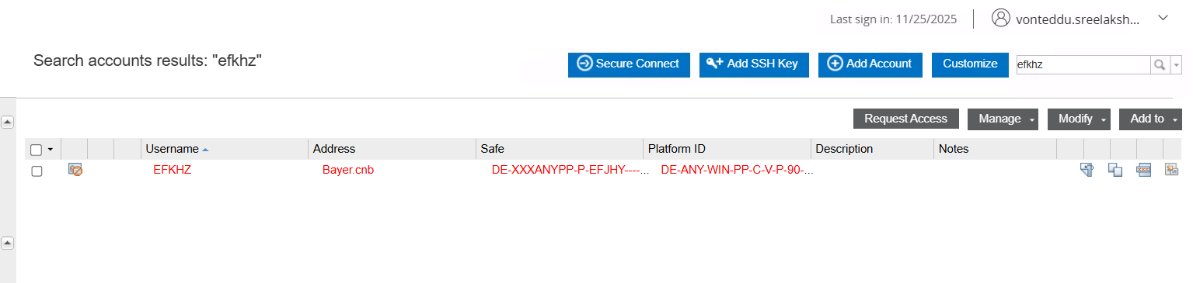
go to chage
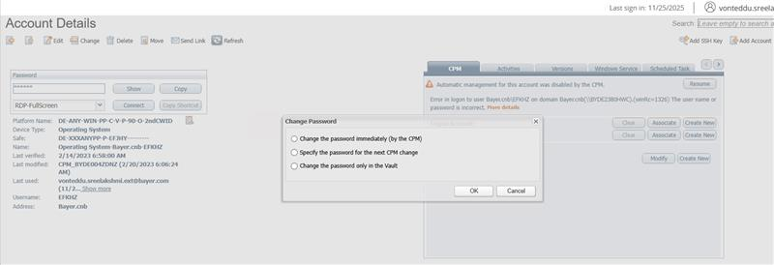
select “change passwd only for vault” then give correct passwd (if not working check with AD team for link to change 2cwid Passwd)
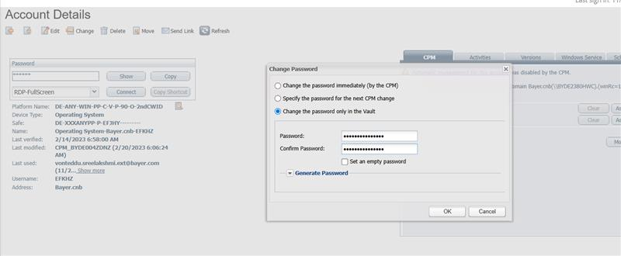

check given passwd correct or not
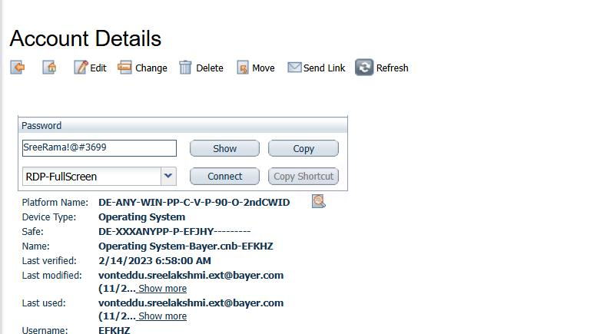

change-select first option then give OK
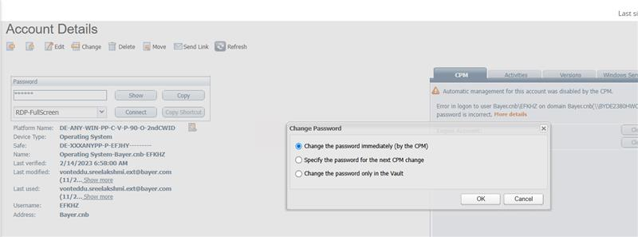

Check you’re a/c is Green should/synced and check passwd working or not
